**Oracle 18c Installation and configuration guide**

|  |  |  |  |
| --- | --- | --- | --- |
| **Document Name** | **Version** | **Prepared by** | **Reviewed by** |
| Oracle 18c Installation and configuration guide | v.01 | Tarunendra Tripathi | Sumit Malhotra |
|  |  |  |  |

Contents

Introduction 1

Download MobaXTerm Client on windows 1

Oracle Installation File 2

Installation Steps 2

# Introduction

This document contains the installation and configuration of Oracle18c on RHEL environment.

# Download MobaXTerm Client on windows

Download below version of mobaXterm Client on windows.

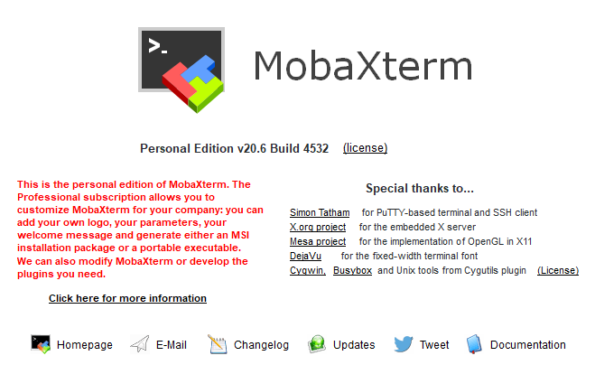

# Oracle Installation File

Download Oracle 18c installation file from Oracle official website and place into the installation directory under **/opt/**

# Installation Steps

Navigate and connect to mobaXterm for oracle installation.

In MOBXterm >>>>

[oracle@ETADEVOPSDB01DEV ~]$ cd /oracle/db_setup/

[oracle@ETADEVOPSDB01DEV db_setup]$ ./runInstaller

Launching Oracle Database Setup Wizard...

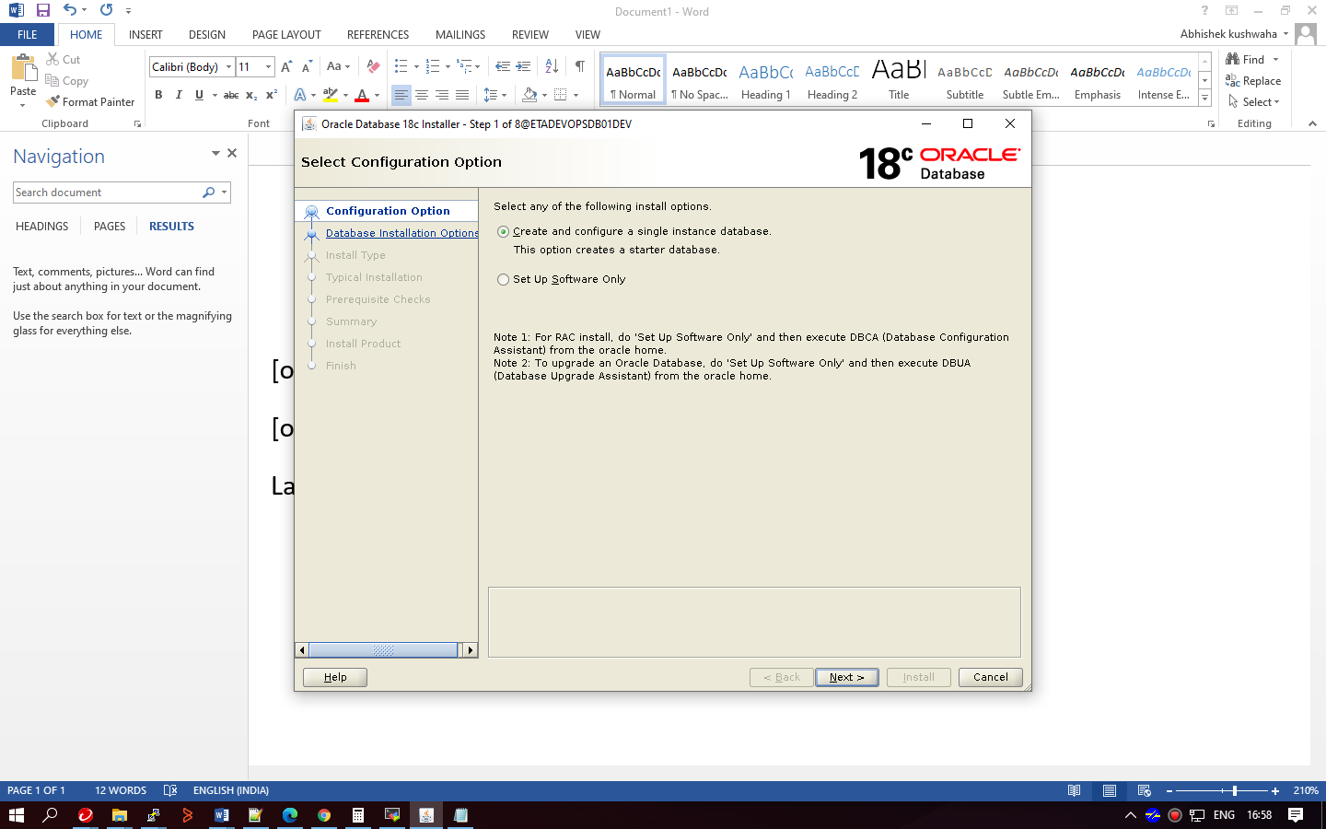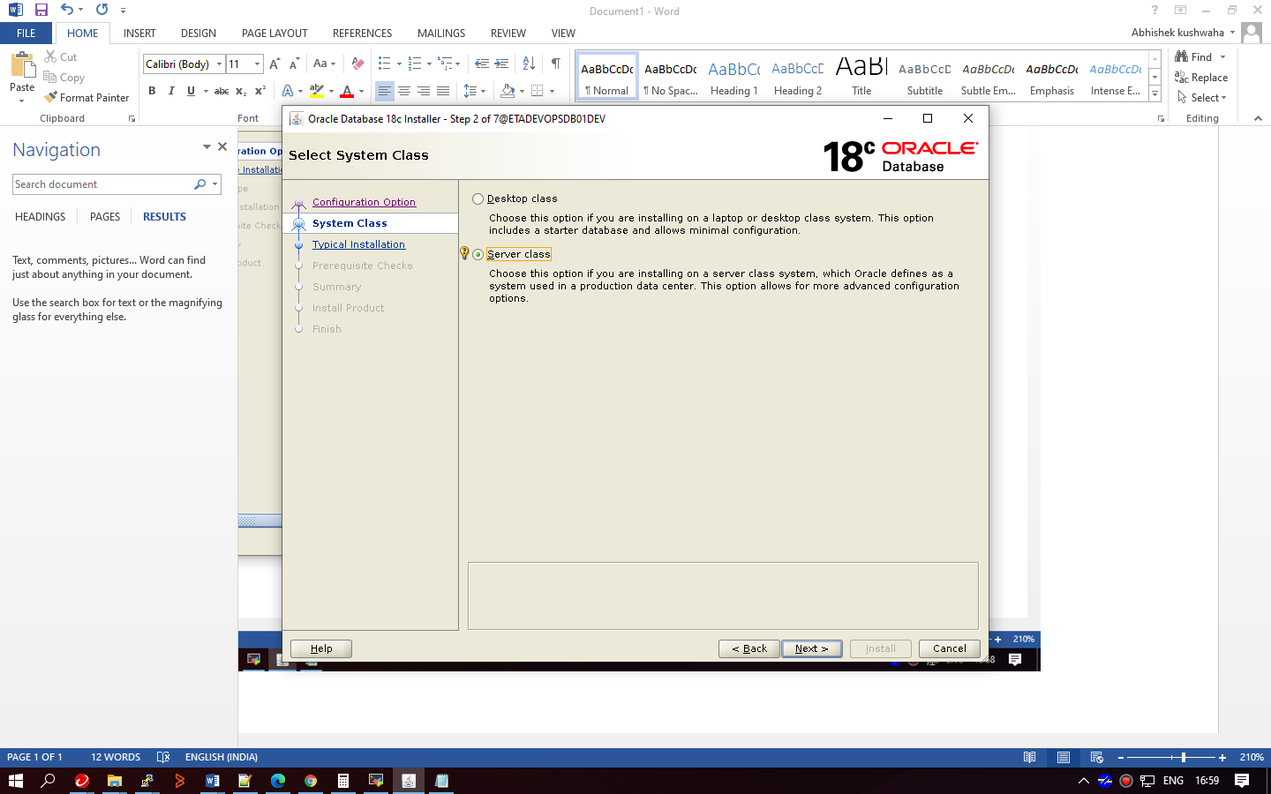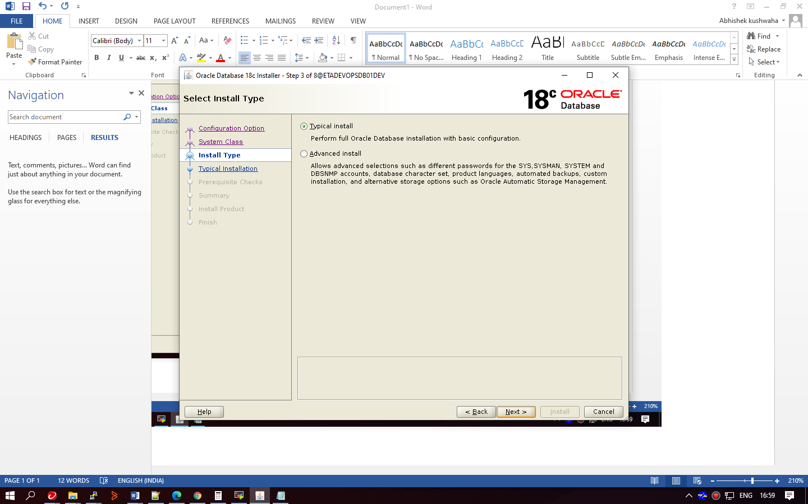

Create directoiry inside /oracle :

Cd /oracle

Mkdir orabase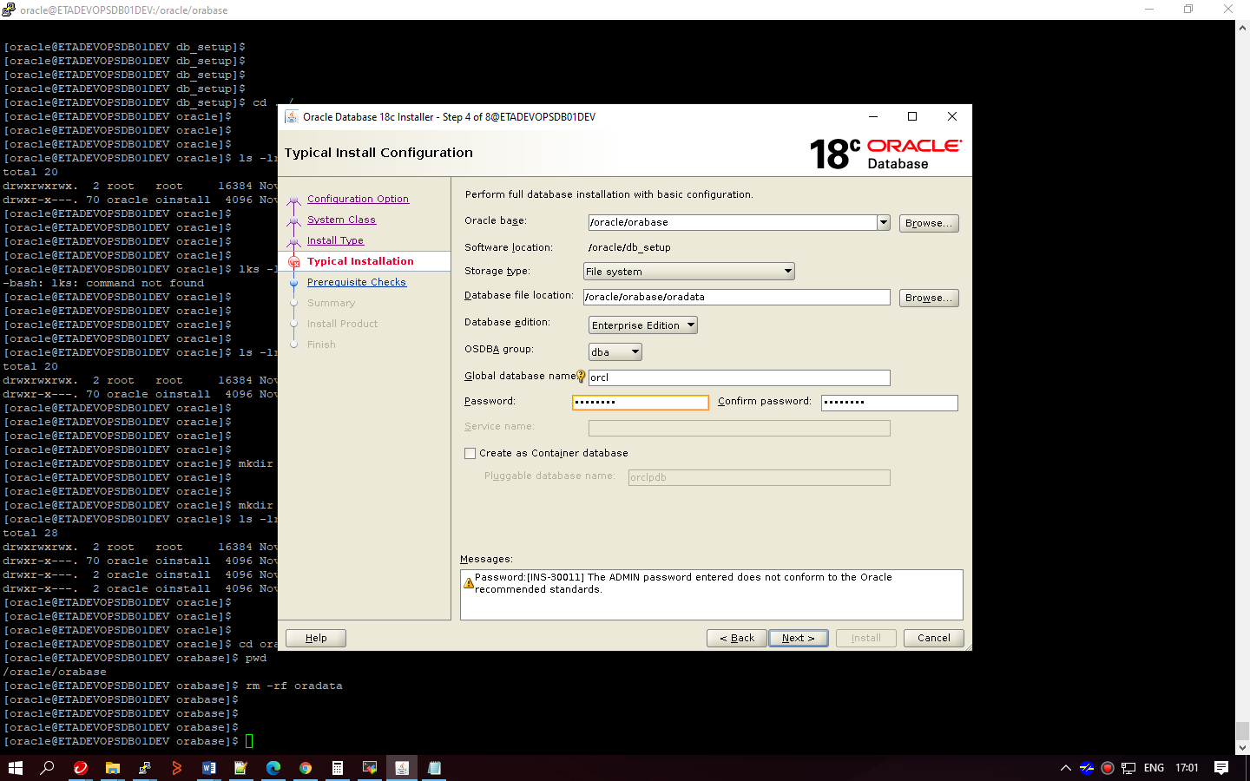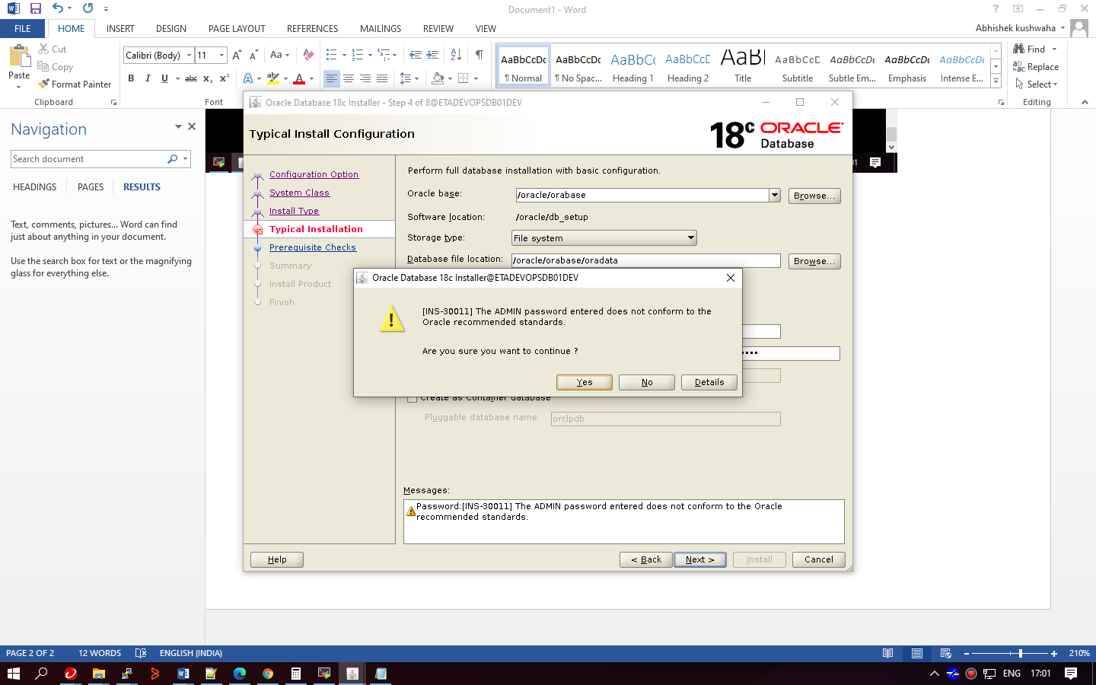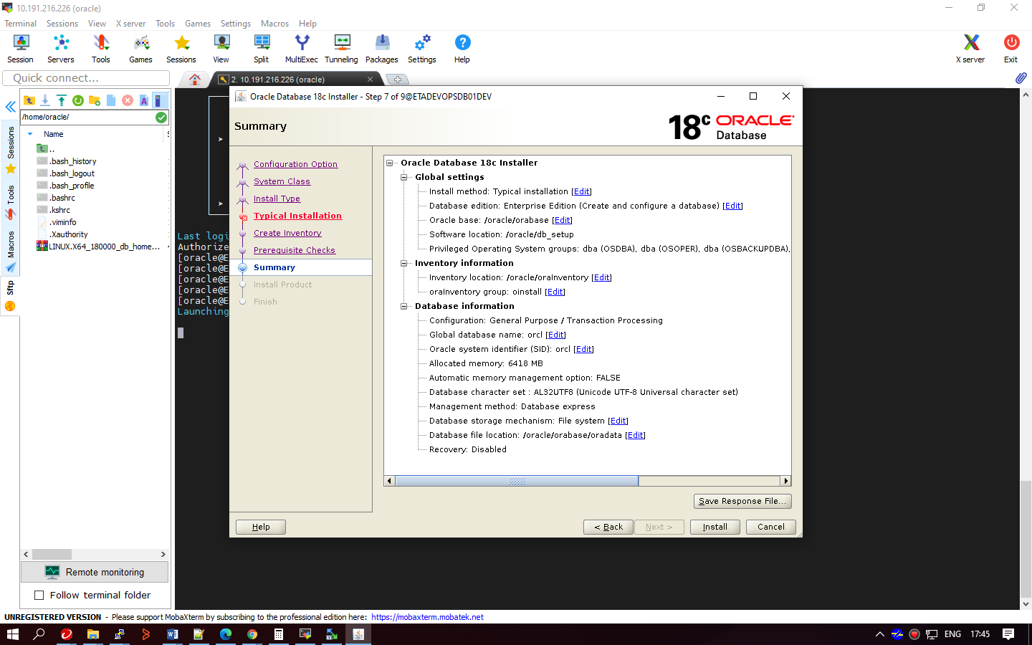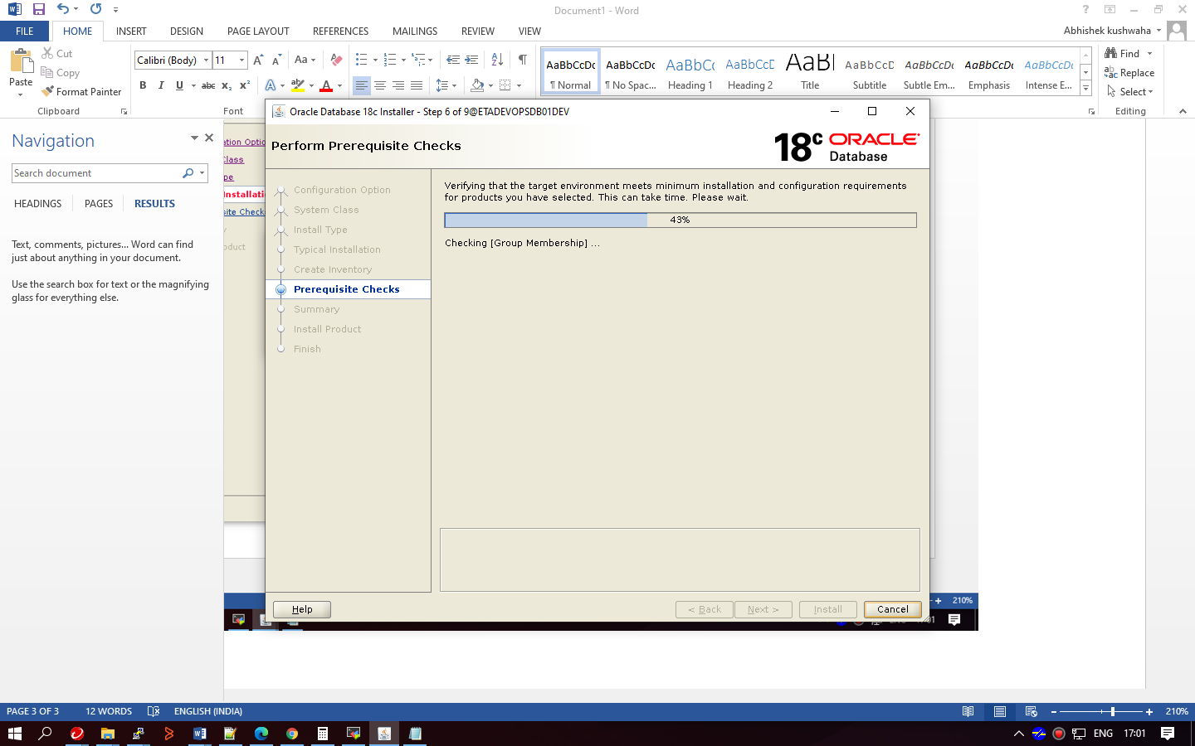

Failed for package :

“compat-libstdc++-33-3.2.3-72.el7.x86_64.rpm”

Copy package to server /tmp from desktop “Downlaod”

As root user,

>> cd /tmp

>> ls -lrt “compat-libstdc++-33-3.2.3-72.el7.x86_64.rpm”

>> yum localinstall “compat-libstdc++-33-3.2.3-72.el7.x86_64.rpm”

(follow requested instructions … Y…Y)

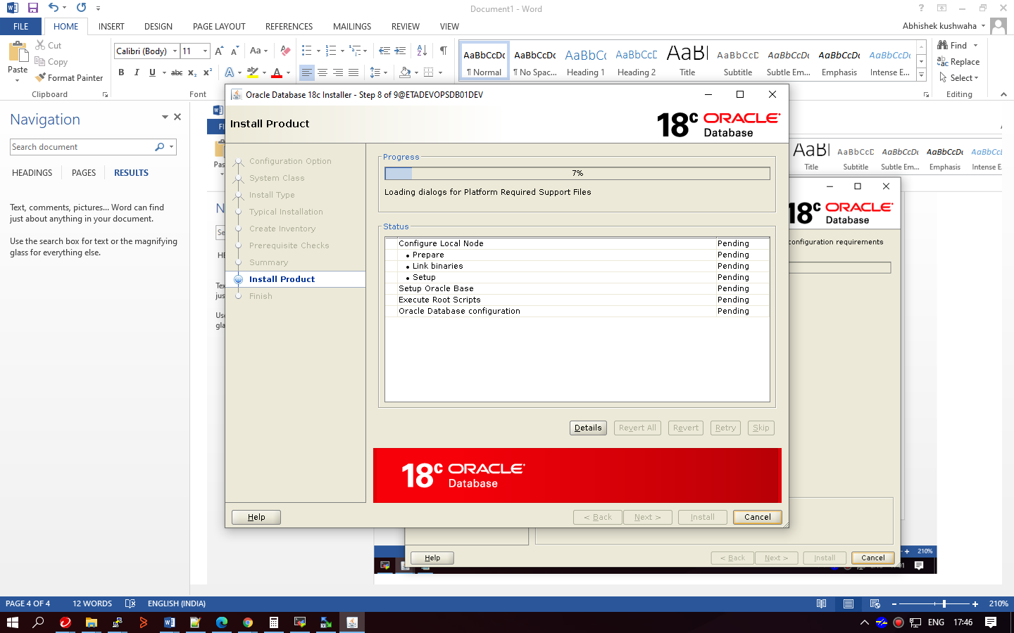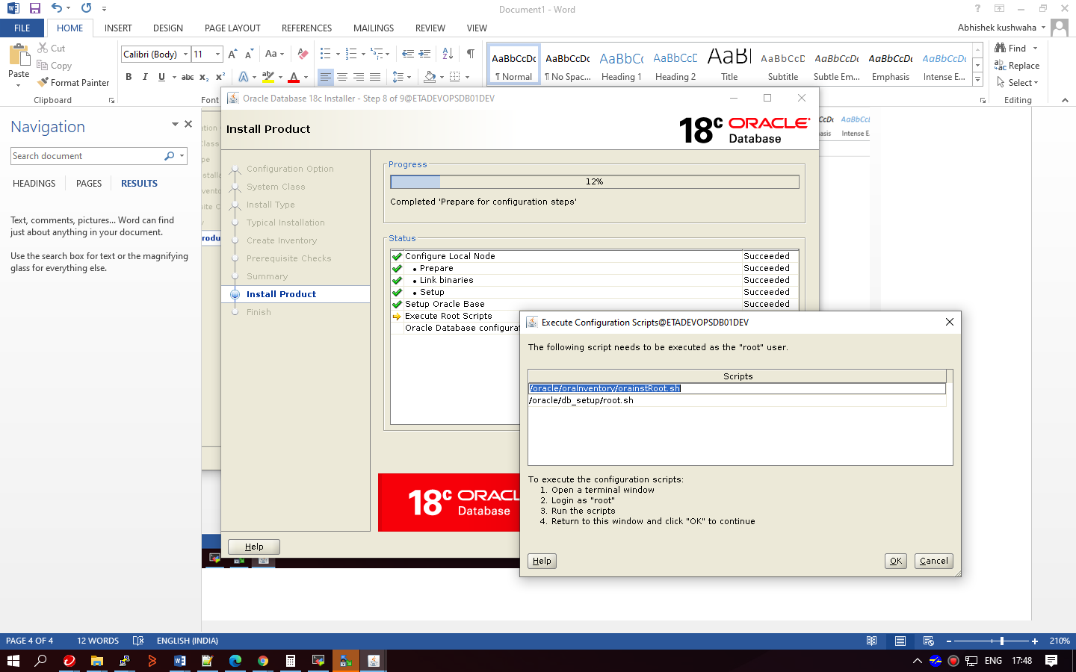execute requested scripts as root user,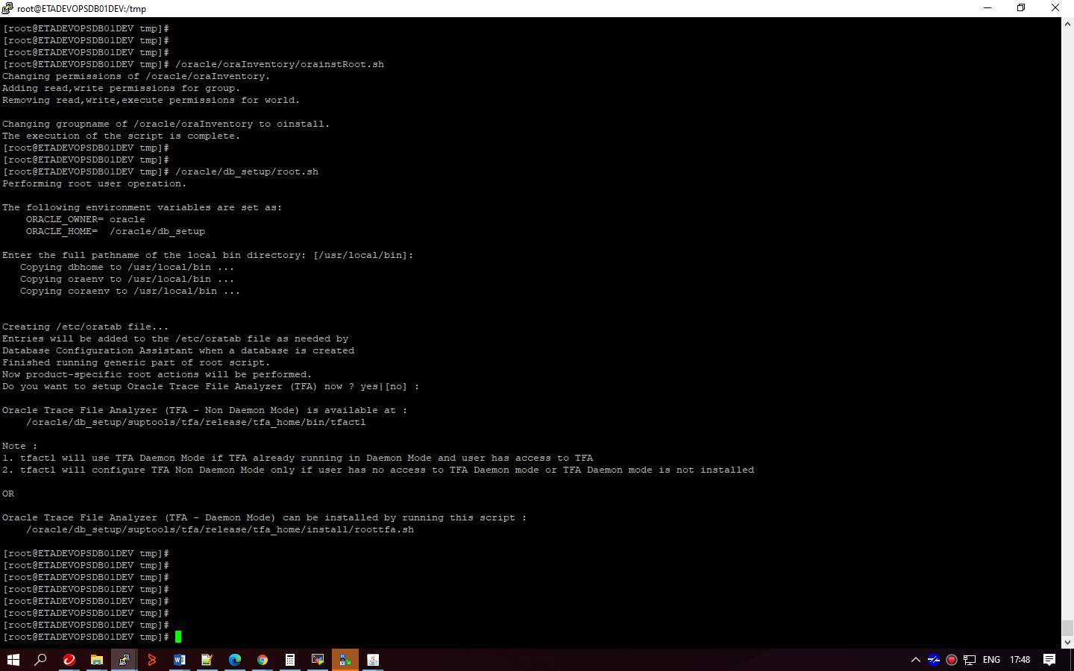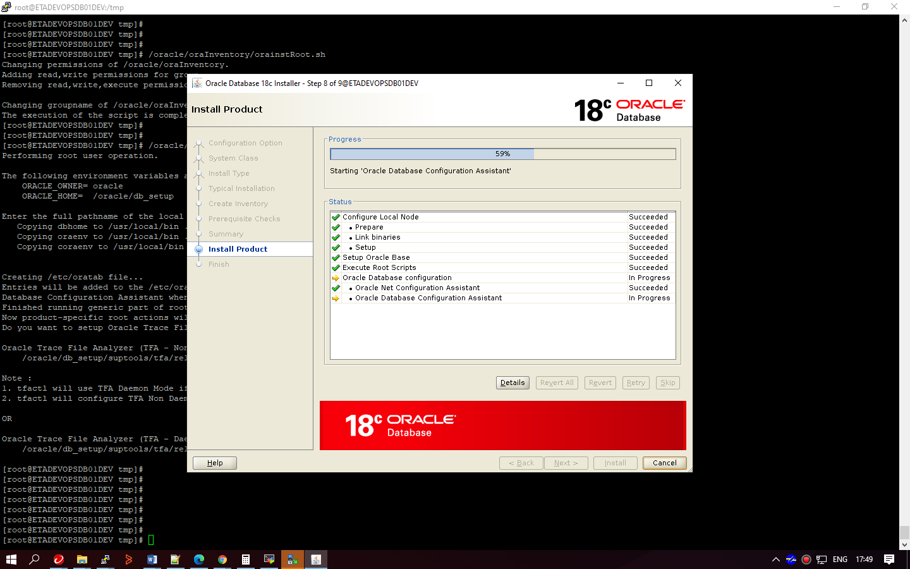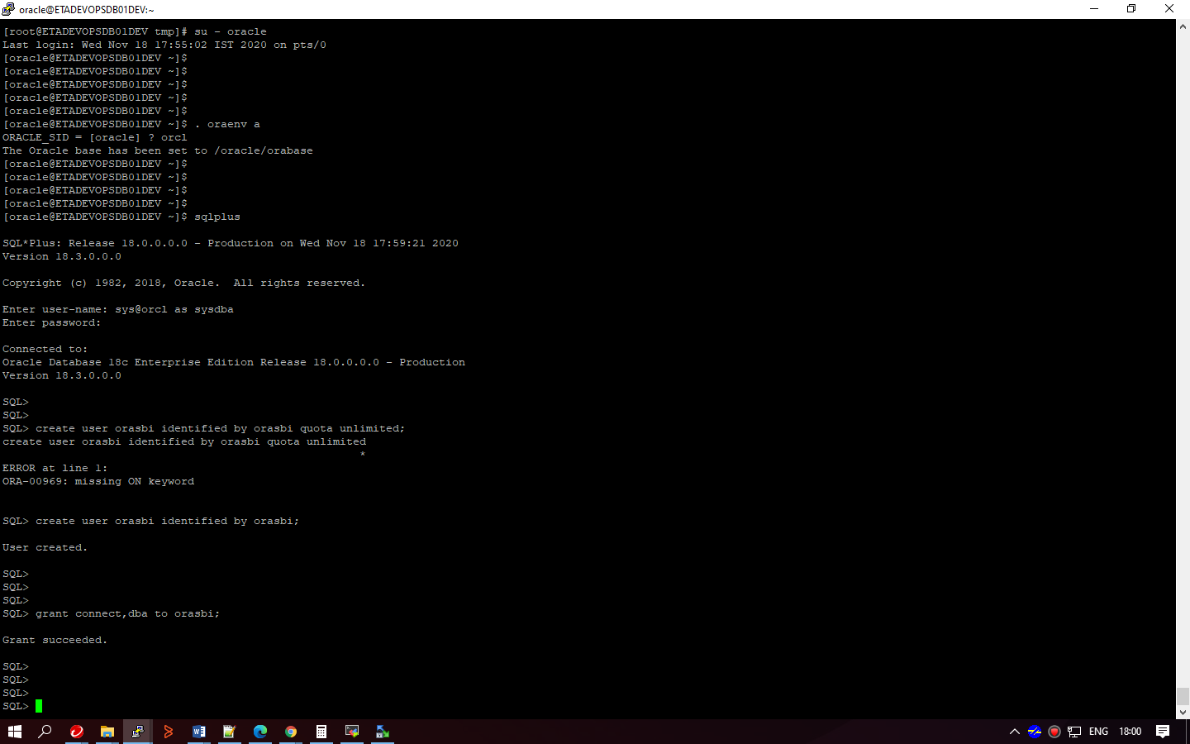

Listener :

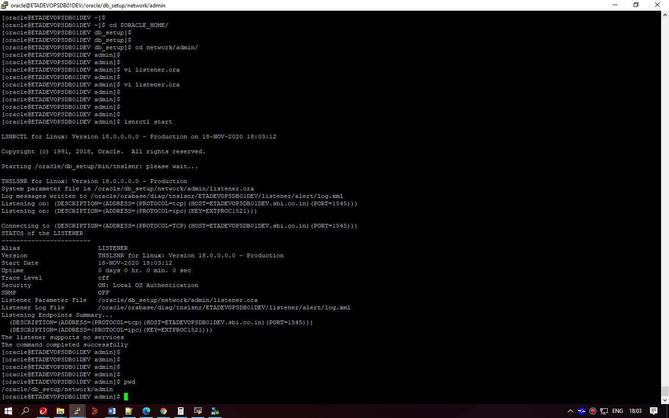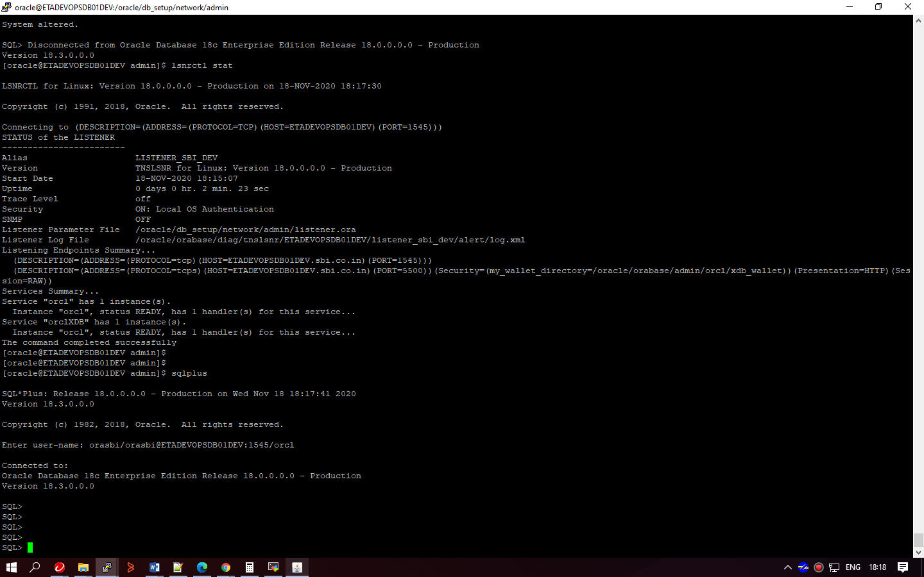

orasbi/orasbi@ETADEVOPSDB01DEV:1545/orcl

DB startup:-

bringing database up

. oraenv

orcl

sqlplus

sql> Startup;

exit

bringing listener up

lsnrctl start <listener_name>

-------------------------------------

1 xclock

2 cat /etc/ssh/ssh_config

3 vi /etc/ssh/ssh_config

4 su root

5 ls -ltr

6 cd /oracle/

7 mkdir db_setup

8 cd db_setup/

9 cp /home/oracle/LINUX.X64_180000_db_home.zip .

10 ls -lrt

11 unzip LINUX.X64_180000_db_home.zip

12 ifconfig

13 cd ../

14 ls -lrt

15 lks -lrt

16 ls -lrt

17 mkdir orabase

18 mkdir oradata

19 ls -lrt

20 cd orabase/

21 pwd

22 rm -rf oradata

23 top

24 df -h

25 cd

26 cd /tmp

27 ls -lrt

28 cd

29 cd vmware-root_776-2965448177

30 cd

31 cd /oracle/db_setup/

32 ls -lrt

33 cd bin/

34 ./dbca

35 cd ../

36 ./runInstaller

37 . oraenv a

38 cat /etc/oratab

39 . oraenv a

40 sqlplus

41 ps -ef |grep tns

42 lsnrctl stat

43 sqlplus

44 sqlplus sys@orcl as sysdba

45 cd /oracle/db_setup/

46 ./runInstaller

47 . oraenv a

48 sqlplus

49 tnsping orcl

50 lsnrctl stop

51 cd $ORACLE_HOME/

52 cd network/admin/

53 vi listener.ora

54 lsnrctl start

55 pwd

56 sqlplus

57 cat /etc/hosts

58 vi listener.ora

59 lsnrctl reload

60 sqlplus

61 lsnrctl stat

62 sqlplus

63 lsnrctl stat

64 vi listener.ora

65 sqlplus

66 lsnrctl stop

67 lsnrctl start

68 sqlplus

69 ls -lrt

70 cat tnsnames.ora

71 vi tnsnames.ora

72 lsnrctl reload

73 tnsping orcl

74 sqlplus

75 lsnrctl stat

76 vi tnsnames.ora

77 ping ETADEVOPSDB01DEV

78 vi tnsnames.ora

79 vi sqlnet.ora

80 vi listener.ora

81 lsnrctl stop

82 lsnrctl start

83 lsnrctl stat

84 sqlplus

85 ps -ef |grep tns

86 sqlplus

87 lsnrctl stat

88 lsnrctl stop LISTENER

89 lsnrctl start LISTENER

90 sqlplus

91 cat listener.ora

92 cat tnsnames.ora

93 lsnrctl stop

94 ps -ef |grep tns

95 lsnrctl start LISTENER_SBI_DEV

96 cat listener.ora

97 ps -ef |grep tns

98 lsnrctl stat

99 sqlplus

100 lsnrctl stat

101 cat tnsnames

102 cat tnsnames.ora

103 cat listener

104 cat listener.ora

105 sqlplus

106 lsnrctl stat

107 sqlplus

108 ls -lrt

109 vi listener

110 vi listener.ora

111 vi tnsnames

112 vi tnsnames.ora

113 sqlplus

114 . oraenv a

115 cd $ORACLE_HOME

116 cd bin/

117 ./netca

118 hoistory

119 history